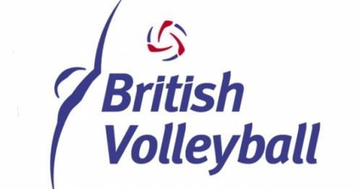
British Volleyball Federation Annual Anti-Doping Activity Report
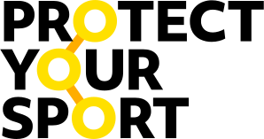
2021-2022 Season

1. Overview
This report covers the anti-doping activities of the British Volleyball Federation (BVF) during the 2021-2022 season. The BVF acts as a conduit for the four home nations, and therefore the majority of the anti-doping activities take place within the home nations, of which any athlete receiving funding from the BVF are part of.
Due to Covid restrictions there were very limited training and competition activities for the GB teams at the start of the year. This includes pathway activities of the home nation associations, and no domestic leagues.
However with the resumption of training and competition at the later end of 2021, home nations and athletes have resumed their plans for anti-doping activities within their area.
2. Education
Due to the implementation of the UKAD Assurance Framework across all home nations and NGB’s, a huge amount of work has been put in place to ensure robust education and monitoring of athletes and support personnel will occur. The BVF have also just been placed onto the Clean Sport Hub to complete their own UKAD Assurance Framework (beginning February 2022), and therefore the work is still underway in collating all of the information required to successfully complete this.
The home nations of England and Scotland have completed or almost completed their Frameworks with sign-off, and have begun to implement their Clean Sport Education Strategy which covers all GB Funded athletes on the BVF programmes. This can be found on their respective websites or through their anti-doping leads. Wales and Northern Ireland are in the process of assembling their own UKAD Assurance Frameworks.
In addition, any international beach, or Indoor volleyball athlete has to complete the FIVB Clean Sport education programme before they are allowed to compete internationally. This is held on the FIVB database and checked before each competition. I am yet to confirm Sitting
This year, athletes identified in the long list for beach volleyball ahead of Birmingham 2022, are taking part in the sessions organised by UKAD (Clean Sport Education sessions).
3. Communication
Website
The BVF website has been updated to include an Anti-Doping section, which features all essential anti-doping information; the Prohibited list, Global DRO, TUEs, 100% me, as well as information on how to report any violations.
Prohibited List and TUE communications
The BVF along with the home nations will ensure that each year the updated Prohibited List along with any TUE communications are sent and documented to athletes and support personnel.
Pro-active communications
The BVF has recently updated all of their social media platforms (facebook, twitter and LinkedIn), and will regularly post, follow and share UKAD’s positive anti-doping messages. This will include promoting Clean Sport Week activities on social media.
4. Testing
With no international competition or training for the GB Sitting Volleyball teams this year, none of the players were tested by the International Federations. Beach Volleyball athletes who have resumed competing have the right to be tested at any competition they enter or within their training environment.

